Medway and District Caledonian Association
27th November 2014
Tim Bowden
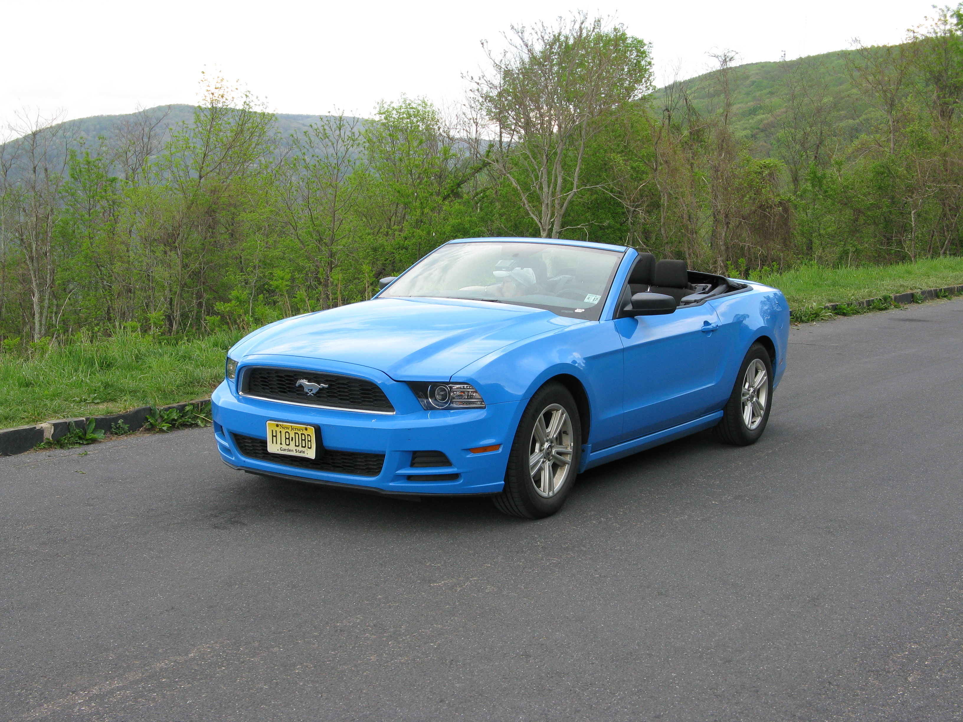

THE MACHINE WITHOUT HORSES (J8x32) 3C (4C set)

MACDONALD OF THE ISLES (S3x32) 3C Set

MAIRI'S WEDDING (R8x40) 3C (4C set)

MACLEOD'S FANCY (J4x32) 4C set

MIDNIGHT OIL 1 (J5x48) 5C set

THE MINISTER ON THE LOCH (S3x32) 3C set

Interval

MUIRLAND WILLIE (J8x32) 3C (4C set)

DOM

MORAY RANT (S3x48) 3C set

MRS STUART LINNELL (R8x40) 3C (4C set)

MY HEATHER HILLS (J3x48) 3 C set with 1M in 3rd place & 3M in 1st place

NOTTINGHAM LACE (R96) Sq.Set

THE NURSERYMAN (J8x32) 3C (4C set)

NEIDPATH CASTLE (S3x32) 3C set

Extras

MONTGOMERIES' RANT, MISS JOHNSTONE OF ARDROSSAN & MOFFAT WEAVERS

